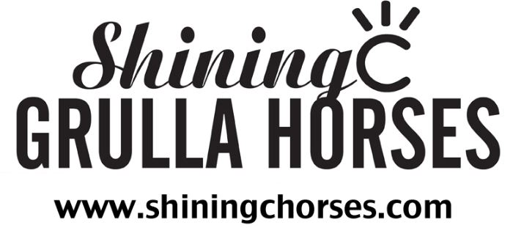

EQUINE SALE AGREEMENT

STATE OF TEXAS §
§ SS:
COUNTY OF HUNT §

- PARTIES

This EQUINE SALE AGREEMENT (“Agreement”), dated this ______day of _____________________, 20______, is made by and between _____________________________________________________________, having an address at ____________________________________________________________________________, ______________________________, _____________ , hereinafter called BUYER (whether one or more), and SHINING C GRULLA HORSES, having an address at 310 South Santa Fe Street, Wolfe City, TX 75496, hereinafter called SELLER.
- HORSE PURCHASED

This agreement shall apply to the following horse:

Registered Name or Sire/Dam: ____________________________________________________

Gender: Stallion / Gelding / Mare

Date of Birth: _________/___________/___________

AQHA Registration Number: ___________________________________________

APHA Registration Number: ___________________________________________

Color: __________________

SELLER will provide original Color Panel test results to BUYER? YES / NO Results: _________________

SELLER will provide original 5-Panel N/N results to BUYER? YES / NO
- TERMS

CASH SALE YES / NO

Sale Price: ___________________________________________.

Received by: ____________________________________________Date ________/________/20_______.

FINANCE PLAN YES / NO

Sale Price: ____________________________________________.

Down Payment: ________________________________________.

Received by: ________________________________________________Date ________/________/20_______.

Outstanding Balance: ___________________________________.

Monthly Installments: ___________________________________.

BUYER hereby agrees to pay SELLER a total of ________ monthly installments of the above amount. Installments shall be due monthly, beginning 30 days from the date of this agreement. The installments will be considered late if they are not received by the ________ day of each month. BUYER further agrees that the entire outstanding balance must be received in full by SELLER by the _________ day of ___________________, 20_______. This date shall be known as the “Maturity” of this agreement.

- LATE PAYMENTS

BUYER shall have a 30-day grace period for each payment. If any installment is more than thirty (30) days late, SELLER retains the right to void this agreement without notice, and retain possession and sole ownership of said horse.

- REFUNDS

BUYER understands that ALL payments made to SELLER are Non-Refundable.

- EQUINE CARE

It is hereby mutually agreed upon that all veterinarian and farrier bills shall be the sole responsibility of BUYER from the date of this agreement forward. Furthermore, BUYER will be responsible for any and all expenses for vaccinations, worming, coggins, and health papers that SELLER deems necessary for said horse to have. SELLER will provide all general care including feed and boarding until the maturity date of this agreement. If horse remains in SELLER’S care beyond the “Maturity” date of this agreement, a “Boarding” fee of $10.00 (Ten and 00/100 Dollars) per day will be charged to the BUYER for the continuing care of said horse.

- INSURANCE / RISK OF LOSS

BUYER assumes all risk of loss to horse including but not limited to death, theft, injury, and sickness, unless said incident was a direct result of negligence on behalf of SELLER. SELLER strongly recommends that BUYER purchase insurance for said horse.

- BRANDING / FOAL STARTING

SELLER will freeze brand said horse/foal with the “SHINING C” brand on the left shoulder. All foals to be sold by SELLER will complete SELLER’s preschool program where foal will learn to lead, tie, load, pick-up feet and other basic ground skills.

- SELLER’S REPRESENTATIONS AND WARRANTIES

The seller makes the following representations:
9.1 SELLER makes no warranties whether expressed or implied, including but not limited to any implied warranty of merchantability or fitness for a particular purpose. The purchase of this horse is subject to the terms and conditions of an “as-is” sale.
9.2 SELLER is the sole owner of said horse and has the authority to enter into this agreement.
9.3 There is no lien or encumbrance on said horse.
9.4 Upon Seller’s receipt of the purchase price, in full, of said horse, SELLER shall provide BUYER with registration papers, if any, and all other documents necessary to transfer registration of the horse from the SELLER to the BUYER.
9.5 SELLER agrees to register foals, once a registration name has been agreed upon by both BUYER AND SELLER. Furthermore, SELLER agrees to send the original registration papers and signed transfer papers to the BUYER as soon as SELLER receives them back from the applicable registration organization.

- ASSIGNMENT

No party shall have the right to assign or transfer this agreement without the prior written consent of the other party.

- GOVERNING LAW AND VENUE

This Agreement shall be governed and construed in accordance with the laws of the State of Texas. Any and all disputes must be resolved in Hunt County, Texas. The parties hereto consent to both venue and jurisdiction Hunt County, Texas, and any attempt to pursue legal action in any other state shall be void for lack of jurisdiction in that foreign court

- PRIOR ORAL AGREEMENTS

The foregoing sets out the entire agreement between BUYER and SELLER as to the matters specifically addressed herein and supersedes any prior oral or written agreements or negotiations as to these matters not set out in writing herein.

{SIGNATURES ON THE FOLLOWING PAGE}

BUYER(S):

_________________________________ ___________________________________
SIGN PRINT

_________________________________ ___________________________________
SIGN PRINT

_________________________________
DATE

SELLER:

_________________________________
CASSIDY COBARR, OWNER

_________________________________
DATE

